**How can my group access the Community Fleet?**

**Follow these 3 easy steps!**

**1. Visit our website** [**www.brighterfuturesrhyl.co.uk/en/fleet**](http://www.brighterfuturesrhyl.co.uk/en/fleet)

Navigate to the downloads page then open and complete the membership form, then email this to us. While we review your application, please read our terms and conditions which are also on the website.

*(If you’re struggling to fill out the form, just give us a call)*

**2. Next you will need complete the driver registration form**

Navigate to the downloads page then open and complete the driver registration form, and email this to us. We will need access to a copy of your nominated drivers license during this stage.

*(If you’re struggling to fill out the form, just give us a call)*

**3. Wait for an email from us to confirm your membership**

Once steps 1 and 2 have been completed, you will be able to book the vehicles online. We will send you a short guide on using the online booking system.

**Please note: - Prior to your first booking, we will ask you to confirm you have read and fully understand the terms and conditions of use and offer any training or support you may require.**

A small admin charge* will be payable on a per day basis, this is currently set at: £40 (per day)

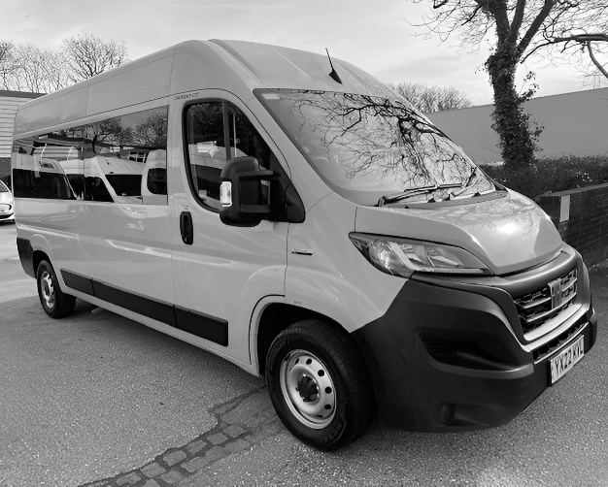

*The admin charges will be used to help us maintain the vehicles. All prices are flexible depending on your group’s financial capacity, in some cases the vehicles can be used without paying an admin charge.



**Sut gall fy ngrŵp gael mynediad i'r Fflyd Gymunedol?**

**Dilynwch y TRI cham hawdd hyn!!**

***1. Ewch i'n gwefan*** [**www.brighterfuturesrhyl.co.uk/en/fleet**](http://www.brighterfuturesrhyl.co.uk/en/fleet)

Naviwch i'r dudalen lawrlwythiadau, yna agorwch a chwblhewch y fform aelodaeth, yna anfonwch hyn atom ni trwy e-bost. Tra rydyn ni'n adolygu eich cais, os gwelwch yn dda darllenwch ein telerau a chyflwr sydd hefyd ar y gwefan.

*(Os ydych chi'n cael trafferth i lenwi'r fform, ffoniwch ni'n syth)*

**2. Nesaf bydd angen i chi lenwi'r ffurflen gofrestru gyrrwr**Ewch i'r dudalen lawrlwytho yna agorwch a chwblhewch y ffurflen gofrestru gyrwyr, ac e-bostiwch hon atom. Bydd angen mynediad at gopi o'ch trwydded yrru enwebedig yn ystod y cam hwn. *(Os ydych chi'n cael trafferth llenwi'r ffurflen, rhowch alwad i ni)*

**3. Aros am e-bost gan ni i gadarnhau eich aelodaeth**

Unwaith y bydd camau 1 a 2 wedi'u cwblhau, byddwch yn gallu archebu'r cerbydau ar-lein. Byddwn yn anfon canllaw byr atoch ar ddefnyddio'r system archebu ar-lein.

**Sylwer: - Cyn i chi wneud eich lle cyntaf, byddwn yn gofyn i chi gadarnhau eich bod wedi darllen ac yn llwyr ddeall y telerau ac amodau defnydd a chynnig unrhyw hyfforddiant neu gefnogaeth y gallai fod angen i chi.**

Mae tâl gweinyddol bach* yn daladwy ar sail bob dydd, mae hyn ar hyn o bryd wedi'i osod ar: £40 (y dydd)

*Mae’r cyfrifon gweinyddol yn cael eu defnyddio i’n helpu ni i gynnal y cerbydau. Mae’r holl brisiau yn hyblyg yn dibynnu ar allu ariannol eich grŵp, mewn rhai achosion gellir defnyddio’r cerbydau heb dalu ffi weinyddol.